***1/How does the web work*?**

-Web servers and web browsers communicate via HTTP

-HTTP ensures that all parts of the web page are delivered

-Web browser decides how these items are displayed

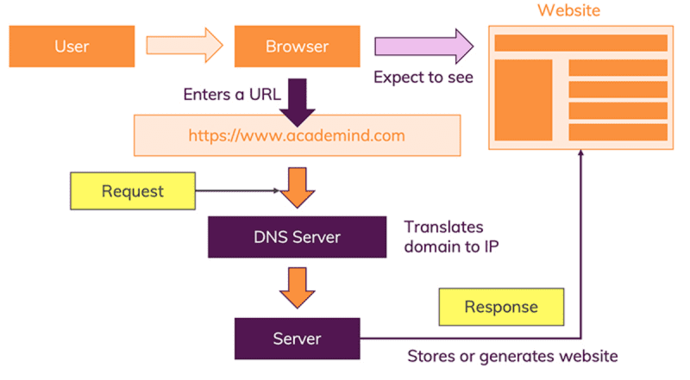

**2/ *What*do you need*to be a web developer?***

**The ability to develop both client and serve : -program web page**

**-program a serve**

**-program database**

**Through knowledge skills of ( HTML-CSS-JAVASCRIPT)**

**3/Why did you choose to learn web development?**

**-To be up to date**

**-There Are Always Freelance Opportunitiesfor jobs**

**-It’s Creative and Fun**